FAST® XDi Race Cam Sync Distributors

Memphis, TN – The new FAST® XDi Race Cam Sync Distributor is an easy solution for those looking to provide an accurate cam sync signal to their aftermarket fuel injection system.

Designed for applications that typically use a crank trigger, this distributor enables proper functioning of sequential fuel injection, individual cylinder spark timing and fuel injector phasing — a must for maximum power and efficiency. Testing has shown the Hall-effect style optical pickup maintains a steady +/- ½-degree trigger signal, unlike competitors’ inductive style pickups prone to signal drift at high RPM.

Ideal for drag racing, high-end street and marine applications, the new FAST® XDi Race Cam Sync Distributor is constructed with a billet housing, precision ground stainless shaft and premium bearings. Hand-assembled parts also maintain consistent shaft end play, eliminating another source of triggering fluctuation. Each distributor comes with a precision machined bronze gear and must be used with a crank trigger and external ignition box.
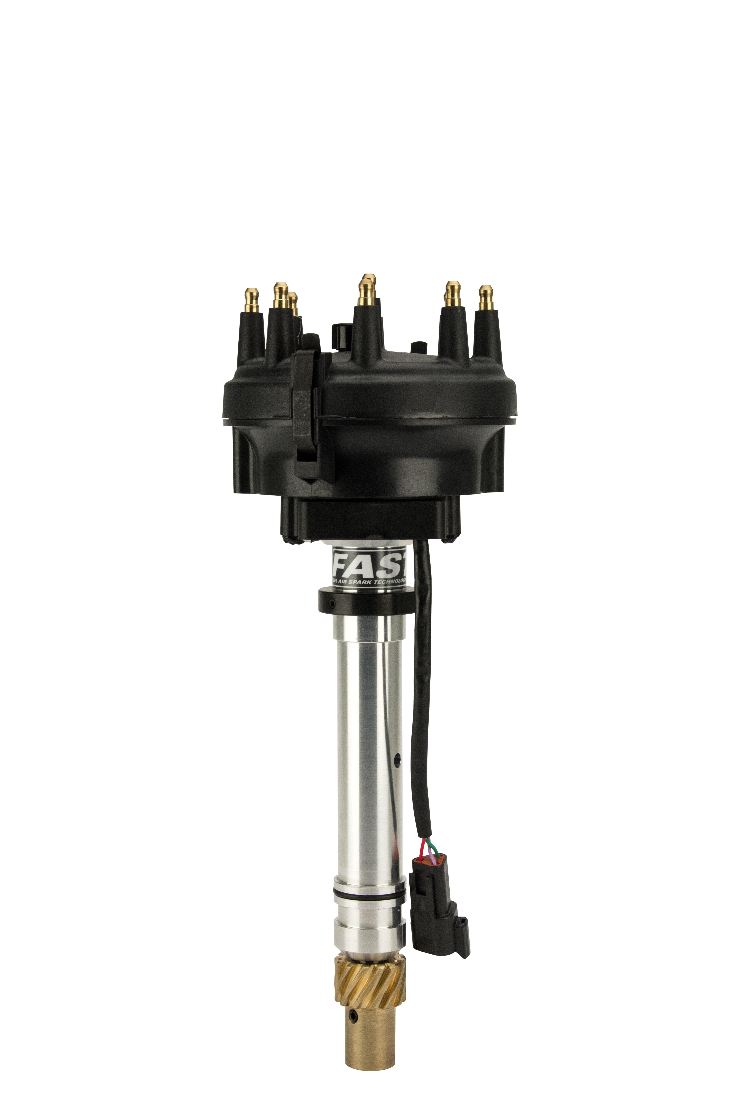
Quick Facts

Product: FAST® XDi Race Cam Sync Distributor
Part Number: See Application Chart
Street Price: $399.95 - $539.95

Social Media Pitch: FAST® XDi Race Cam Sync Distributors provide an easy and precise triggering signal for sequential EFI on crank trigger-equipped engines

Features & Benefits:
- Easy, turnkey solution for supplying cam sync signal to an aftermarket ECU
- Advanced Hall-effect, optical pickup delivers accurate trigger signals at all RPM (+- ½ degree)
- Precision billet construction & assembly maintains consistent shaft end play for triggering stability

APPLICATION CHART ON PAGE 2

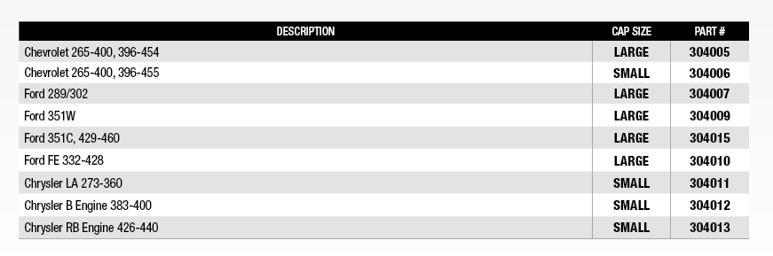

About FAST®

Since 2001, FAST® has been a recognized leader in advanced EFI technology. Now, not only does FAST® offer the components to adapt virtually any engine to fuel injection, it is also an emerging force in the ignition market. With the latest in easy-to-use electronic components, the experts at FAST® have everything you need to make high-tech horsepower. Additional information about FAST® and its products can be found at www.fuelairspark.com or at 1.877.334.8355. Also visit us on Facebook at facebook.com/FASTWins, on Twitter at twitter.com/FASTEFI or on YouTube at CPGNationTV.com.

Media Contact: Cindy Bullion, cbullion@compcams.com, 901.795.2400 ext. 1643

